RC tutorial 002 - Alignment With Spiral

===================================

Revised 2022-10-22

* This tutorial's goal is to teach you about clothoids in RailCOMPLETE tracks.
* Assumed RailCOMPLETE skills: Previous lessons.
* Assumed railway skills: You know about railway geometry - lines, arcs and spirals (clothoids) in the XY plane.
* Time to spend here: 1 hour.
* Suggested reading: “2021-05-23_001 EN Introduction to RailCOMPLETE v2021.0”, which can be downloaded from our web pages.
* Notice to users with non-English versions of AutoCAD – see footnote[1].
* This example was prepared using software release 2022.2.0.7 with Norwegian DNA version “NO-BN 2021.a”,” 2021-11-27T21:11:27+01:00;2021.a”.

1. Start AutoCAD with RailCOMPLETE, then open the ‘National Tutorials’ folder and locate the DWG file named after this tutorial. You can either type **RC-OpenNationalTutorialsFolder** or you can locate the button below the RC logo in the upper left corner of your AutoCAD window.
2. Activate the **RC-ShowAlignmentGeometry** tool to see your changes directly in modelspace while you make modifications to the alignment, and the alignment is selected.  
    Et bilde som inneholder tekst, klokke

   Automatisk generert beskrivelse  
   Make sure that the AutoCAD ‘ortho’ mode is deactivated (functin key **F8**).
3. Start the Alignment Manager from the ribbon, or using command **RC-ManageAlignments**, and select the alignment "T01". It consists of a 250m long tangent line (a straightline segment), then a counter-clockwise turning clothoid from Inf (straight line) to radius 300 m, and finally a 100 m long counter-clocwise circular curve.
4. A ‘spiral’ simply means that we combine to circular arcs of different curvature with a transition curve from one radius to another (one of them could be a straight line). **Clothoids** are a special type of spirals, also called **Euler spirals**. If you imagine running in a car at a constant speed along an alignment featuring clothoids, then a clothoid part corresponds to turning your steering wheel with a constant rotational speed.
5. Positive radius denotes a counterclockwise (CCW) curve, negative radius denotes a clockwise (CW) curve (as seen from the positive Z-axis). Below you can see a positive spiral and curve.  
   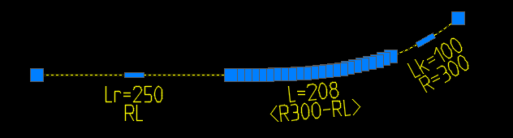

4. Activate the Alignment\Horizontal tab. You will see a datagrid displaying the actual horizontal geometry details of your alignment.

5. Check the "Extended View" checkmark to see more details, such as the clothoid parameter 'A', which equals the square root of the product L*R, where L = full clothoid length and R = end radius. By 'full length' we mean a clothoid that starts or ends with infinite radius (a straightline segment), such as in our T01 example.

6. Uncheck "Extended View" again.

7. Now, let us "tamper" with the clothoid. Select the alignment and locate one of the elongated grips along the clothoid segment. Hover over the grip and select "Convert to Line". The clothoid splits into two clothoids with a line segment between them. Also check out the changes shown in the Alignment Manager datagrid.

8. Use Ctrl+Z to revert to your original clothoid.

9. Now, use **RC-BreakAlignment** (under the ‘Edit’ button) and break the alignment somewhere inside the clothoid. The clothoid splits into two adjacent clothoids. Check them out in the Alignment Manager datagrid.   
  
Note that a topology connection object appeared where the two clothoids meet. Its “SS” annotation is a superposition of “_S” and “S_”, since both alignments meet as “End of alignment / spiral”.  
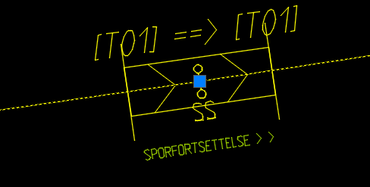

10. Use **RC-JoinAlignments** and join the two alignments again. If you want to preserve the original alignment’s properties (and GUID), make sure that you select the low-mileage part first and the high-mileage part next.  


11. Use the AutoCAD **OFFSET** command to make a regular 2D polyline copy of the original alignment with a constant offset of, say, 50 meters. Select this polyline and use **RC-CreateAlignment** to convert the 2D polyline into a RailCOMPLETE alignment object. Use “Spor” (track) as RC type, and “Enkle skinner og sviller” (Simple rails and sleepers) as the alignment’s Variant. Name it "T02" (in the ‘code’ property). Note that T02 does not contain clothoids, just a lot of circular arcs where the clothoid was.  
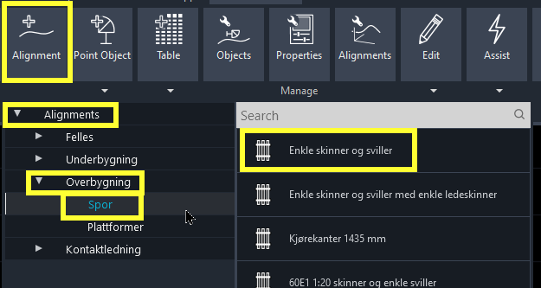

12. In the Alignment Manager, mark the T02 alignment and see that it consists of a large number of circular curves where the clothoid was. This is because an offset tangent line is a line, an offset circular curve is a circular curve, but an offset clothoid is not a clothoid. RailCOMPLETE converts the offset clothoid into small curve segments, each arc segment results from the AutoCAD OFFSET of the original alignment, whose 2D polyline representation in AutoCAD consisted of a series of circular arcs.

13. Draw your own alignments using **RC-CreateAlignment** to become familiar with geometry. Please note that AutoCAD should not be in ‘Ortho’ mode (function key **F8**) when drawing free-hand alignments, since it will be difficult to direct the curvature of a clothoid that way.

14. You may draw a “dead” 2D or 3D polyline with AutoCAD **POLYLINE** or **3DPOLY** and then convert them to RC alignments by selecting them and using **RC-CreateAlignment**. You may create offset alignments from existing alignments using **RC-CreateAlignment** (without preselecting anything), then click the down-arrow on your keyboard to bring up the context menu and select “Offset” as method. ‘Replace’ will preserve properties and GUID as far as possible but removes the source alignment after offsetting it.

14. Play with **RC-BreakAlignment** and **RC-JoinAlignments**.

15. Note: If you use AutoCAD’s **JOIN** command, then it might join the graphics that you see into one polyline, but this will NOT join the RailCOMPLETE alignments "behind the scenes".

Please check our website www.railcomplete.com for updates.  
Corrections and suggestions are welcome to [support@railcomplete.com](mailto:support@railcomplete.com).  
Thank you for using RC Tutorials!

1. Your AutoCAD session has probably been started from a Windows shortcut of the type:  
   “C:\Program Files\Autodesk\AutoCAD 2022\acad.exe” /product ACAD /language “fr-FR”, where “fr-FR” means “French language, France’s version”, or similar, or no language specified (English is the native language for AutoCAD). Native AutoCAD commands may have different names in your language pack, other than the COPY, COPYBASE, FIND etc that you see in our tutorial texts. In order to instruct AutoCAD to accept the native English command name, precede the native (English) command name by an underscore character, ‘_’. For instance: ‘_FIND’ will start AutoCAD’s native ‘FIND’ command even if you are using AutoCAD with the French language pack, where the command in French is called ‘RECHERCHER’.If a command needs an argument ‘ON’, and the French menu says ‘Allumer’, then you can enter ‘_ON’ to instruct AutoCAD to use the option’s native name. Furthermore, the English AutoCAD object selection prompt (command _SELECT) accepts many keyboard shortcuts such as A = (add) add to selection set, R = (remove) remove from selection set and AL = (all) all objects (and many more). These shortcuts are named differently in other language packs. In French they are for instance A=ajouter, S=supprimer, TO=tout. Consult AutoCAD Help in your native language.